Plastic Deformation Energy UMAT
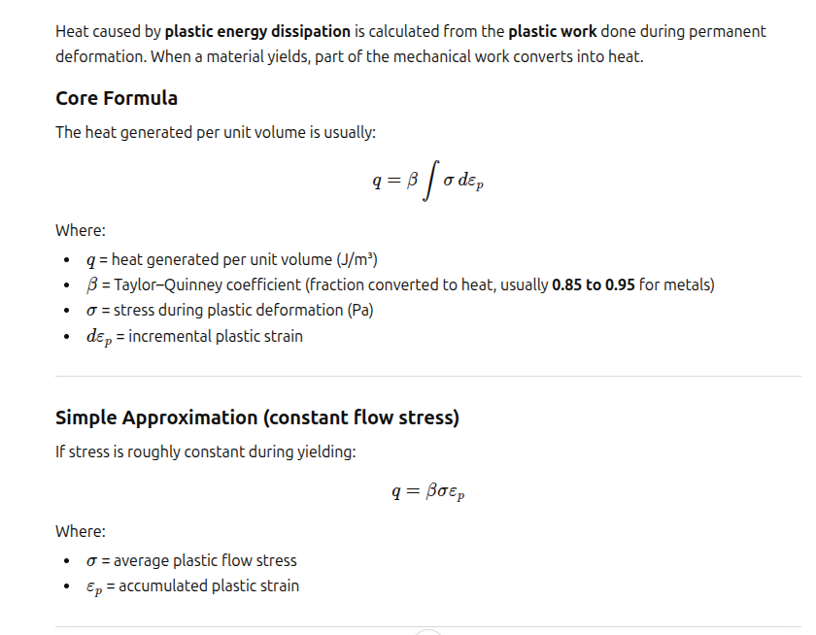
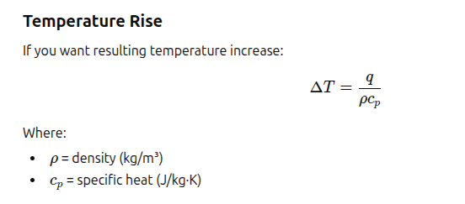

Example Problem
A 1 x 1 x 1 steel block is put into uniaxial tension by restraining one end a displacing the other end as a function of time. E = 200000.0, v = 0.30, the plastic model is perfectly plastic at a yield stress of 220.0. The material density is 7850. and the specific heat capacity Cp = 470.

A spreadsheet was developed to calculate the close formed solution to provide a test case.

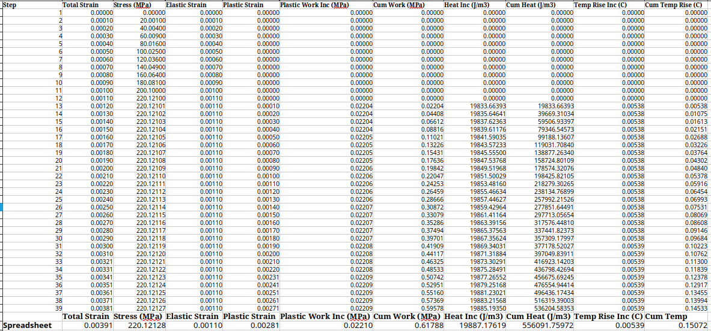
The unit block Displacement and stress

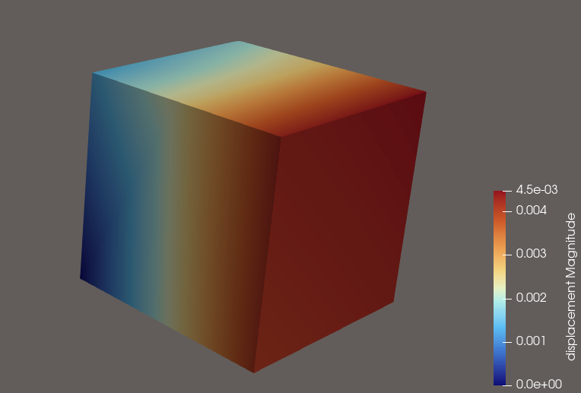

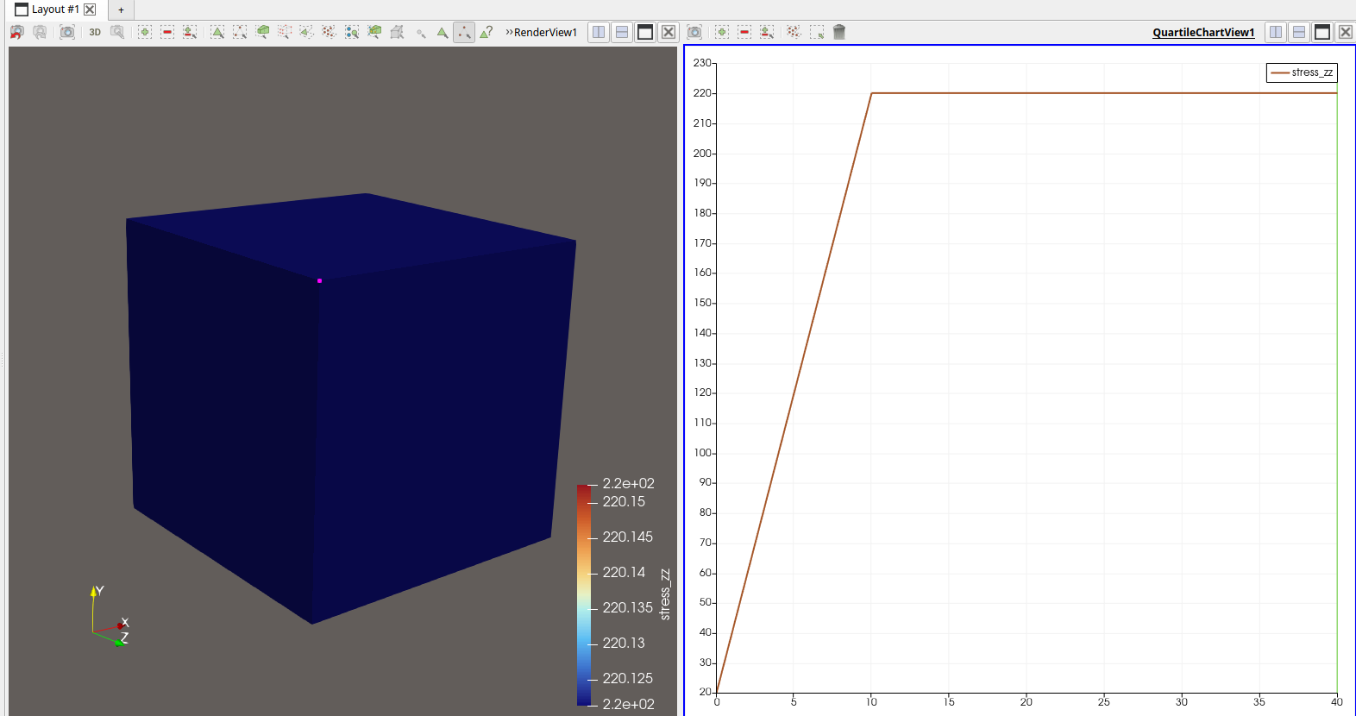
The comparison of the Elmer solution with the UMAT
The material input for the UMAT is as follows

Material 1
Number of Material Constants = Integer 8
Number of State Variables = Integer 0
! List material constants as {Young's modulus, Poisson's ratio,Hardening Slope, Yield, density, Cp,beta, npt, Tsteps, Eout}:
Material Constants(8) = Real 200000.0 0.30 0.1 220.0 7850 470 0.90 2
UMAT Subroutine = File "PDEUmat" "plastic"
Name = "plastic" ! This specifies the CMNAME argument of UMAT
End
The last parameter Eout limits the printed data to 1 selected element, the point of interest where yielding is occurring. This is done to limit the size of the file. The data is calculated for all elements, but unless it is a very small model, printed output would be too large.

A future upgrade could be to add VTU output.

Plots of time histories from output file
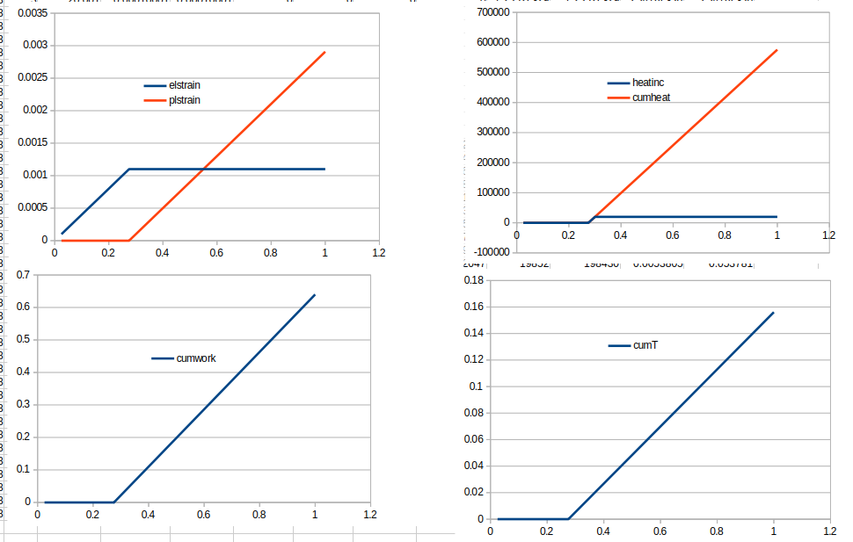
The UMAT was testing on a 2D notched beam model
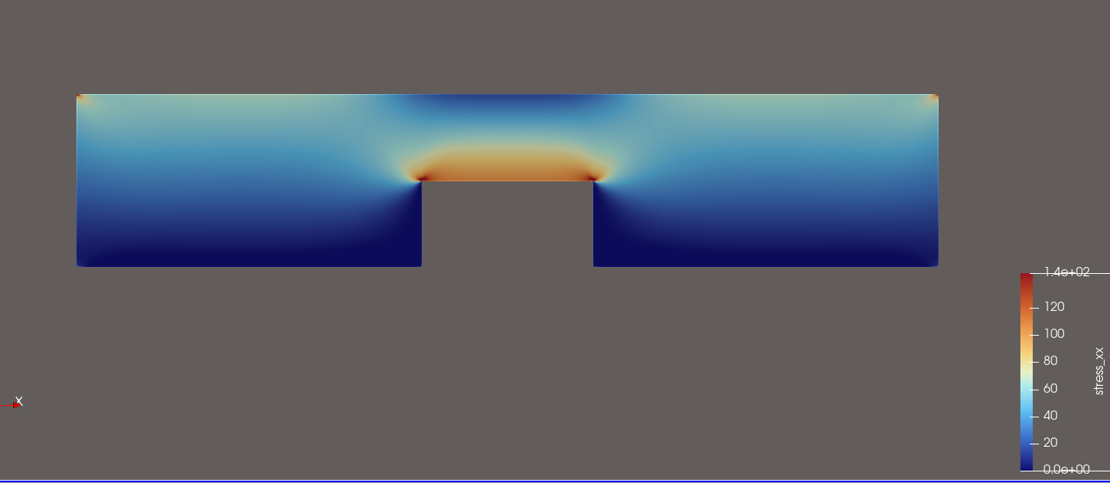

Notch Beam Graphs

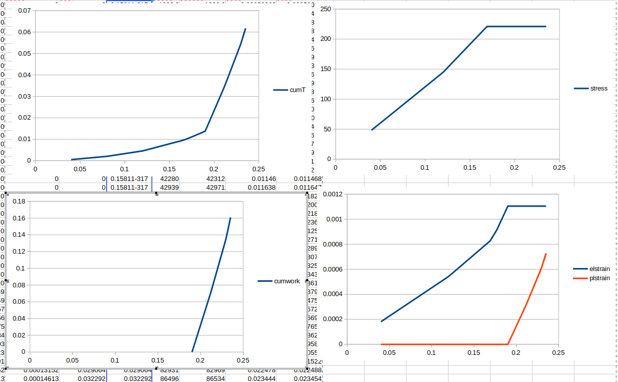

UMAT and test case can be found at

https://github.com/mrkearden/PlasticDisipationEnergy-Elmer-SOlver

